Food Management System

s

Version <1.0>

Revision History

|  |  |  |  |
| --- | --- | --- | --- |
| **Date** | **Version** | **Description** | **Author** |
| <24/12/2020> | <1.1> | Final Draft | Nguyen Thi Ngoc Anh |

Table of Contents

1. Introduction 2

1.1 Purpose 2

1.2 Scope 2

1.3 Definitions, Acronyms, and Abbreviations 2

1.4 References 2

1.5 Overview 2

2. Flow of Events—Design 2

3. Derived Requirements 2

# Introduction

## Purpose

This document describes how the Order Product Use-Case is realized within the design model, in terms of collaborating objects.

## Scope

This document applies to the Food Management System which will be developed by TAT Restaurant.

## Definitions, Acronyms, and Abbreviations

User – a person who use the system, can be customer.

Admin – administrator

## References

None.

## Overview

In the following section, Use-Case Realization Specification of the Order Products Use-Case of the Food Management System is provided in detail. The first section is a textual description of the Use-Case specification. The following section contains diagrams (sequence and collaboration diagrams) describing how the use case is realized in terms of collaborating objects. The third section includes class diagrams with relationships that participate in the realization of the use case. The last section is an analysis of all requirements, such as non-functional requirements, on the use-case realization that are not considered in the design model, but that need to be taken care of during implementation.

# Flow of Events—Design

|  |  |
| --- | --- |
| **Use case** | Order Products |
| **Actor(s)** | Customers |
| **Brief Description** | A customer order product(s) online through the system |
| **Triggers** | Customers click “Order” on interface view selected products |
| **Pre-conditions** | Customers have selected 1 or more dishes and they are in view of the selected products |
| **Post-conditions** | Customers ordered successfully |
| **Main Event Flow** | 1. The customers click on "Order" on the interface of View selected products  2. The system processes and displays the notice of a successful order and switches to the View Order Status interface |
| **Exception Flow** | * 1. Customers have not chosen the item but click on the order   The system displays a notice asking the customers to choose an item before ordering |

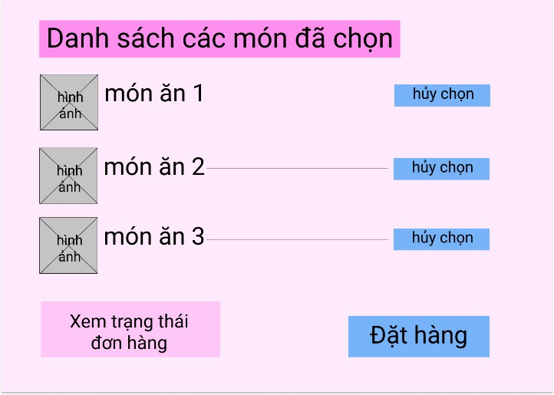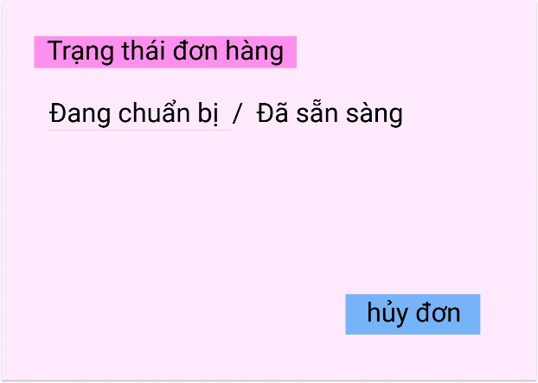

Order successfully

Sequence Diagram:

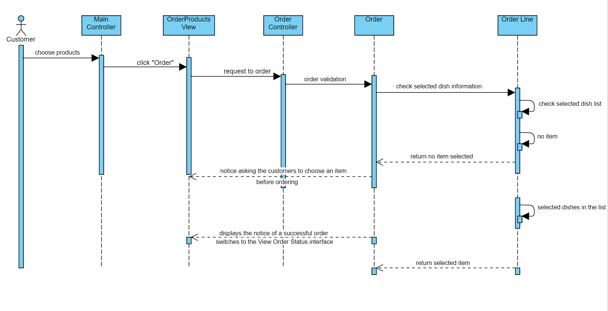

Class Diagram:

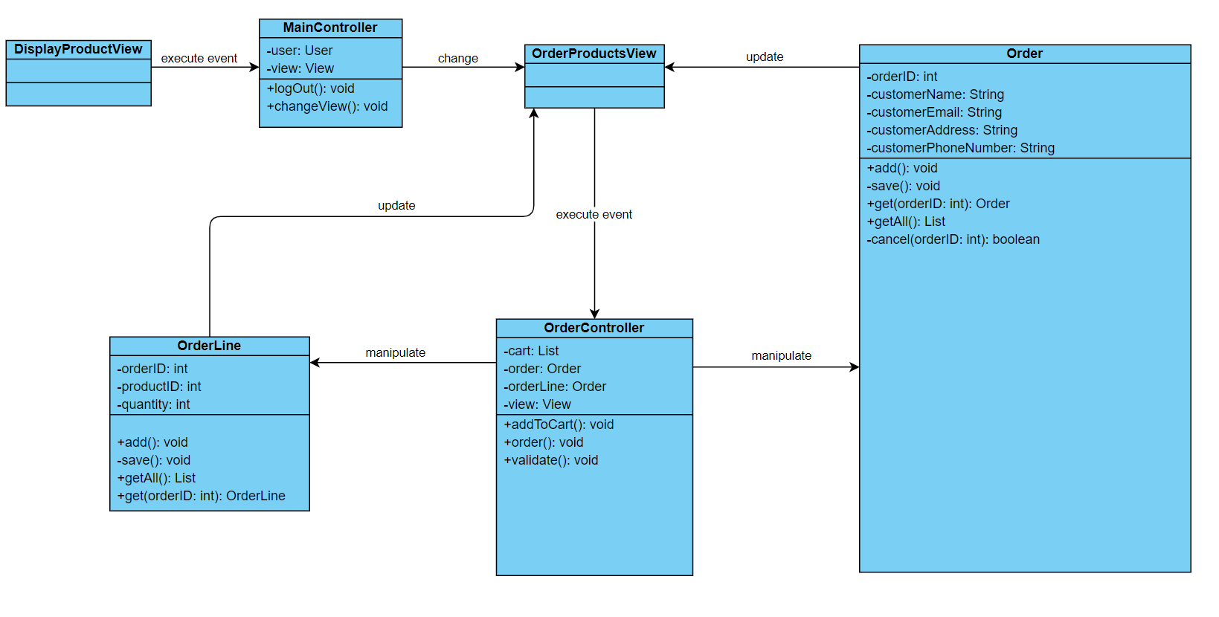

# Derived Requirements

None.